5. Key Results and Discussions
5.1 Key results and discussion
Manufacturing in India has played a significant role in its economic development but companies in the industry have also suffered from internal poor financial performance and external economic shocks. The manufacturing sector contributes to around 37% of the total Corporate Insolvency Resolution Processes initiated in terms of the Insolvency and Bankruptcy Code. It has also been noted that 56% of the cases closed were settled and all other cases ended in liquidation. Moreover, as far as timing for resolution is concerned, the average duration of the process is 683 days as compared to the statutory duration of 270 days. The information presented provides evidence that by the time formal insolvency procedures are initiated, a considerable amount of the company’s worth has already been lost. That is why it is necessary to create the systems that will allow detecting the signs of financial trouble well before the companies are at default or have to deal with insolvency.
The present study was designed to examine whether advanced machine learning models, using both firm-level financial information and macroeconomic conditions, could provide a better early warning system for financial distress in Indian manufacturing firms than the traditional models commonly used in the literature, namely the Altman Z-score and the Springate S-score. Four objectives were developed to address this question. Objective 1 was focused on identifying the financial ratios and firm characteristics associated with financial distress. Objective 2 was aimed at developing and comparing machine learning models for predicting financial distress one year in advance. Under Objective 3, explainable AI techniques were applied to understand which groups of variables had the greatest influence on the predictions made by the models. Objective 4 was used to examine whether the performance and results of the selected model remained consistent across different sectors, regulatory periods, and the COVID-19 period. The findings from these four objectives have been presented in the following sections according to the analytical methods used and the results obtained. The findings have then been brought together to discuss their practical, economic, and policy implications.
5.1.1 Analysis
Objective 1: Financial Ratios and Firm Characteristics Associated with Financial Distress
The first objective focused on identifying the firm-level financial ratios and characteristics that were most closely associated with financial distress among Indian manufacturing companies. The role of macroeconomic conditions was also examined to determine whether they had any additional effect after the financial position of the firms had been considered. For this analysis, a firm-year panel was prepared using the CMIE ProwessIQ micro-level database. The data covered financial years 2014 to 2025 and included 36,984 firm-year observations from 3,082 manufacturing companies. Annual macroeconomic data were collected from the Reserve Bank of India Handbook of Statistics, the World Bank, and the Economic Policy Uncertainty Index website. The firm-level and macroeconomic datasets were then matched using the financial year.
The analysis for this objective was based on the relationship between the financial position of a firm in a particular year and its distress status in the same year. It was therefore treated as an association analysis rather than a forecasting exercise. The one-year-ahead prediction analysis, with controls applied to avoid data leakage, was undertaken separately under Objective 2. Financial distress was represented using a binary variable. A firm-year was classified as distressed when either the firm's net worth was negative or its interest coverage ratio was below 1.0 while profit after tax was also negative. The first condition represented balance sheet insolvency, while the second indicated that the firm had been unable to meet its interest obligations while reporting a loss. Firm-years that did not meet either condition were classified as non-distressed.
The financial ratios included in the analysis covered liquidity, leverage and solvency, profitability, efficiency, cash flow, and debt-servicing capacity. Two firm characteristics were also considered: firm size, measured as the natural logarithm of total assets, and firm age. These measures were calculated using Python. Extreme values were expected to occur in some of the accounting-based ratios, particularly in ratios such as interest coverage where the denominator could become very small. To reduce the influence of such extreme observations, the continuous financial ratios were winsorized before the univariate and multivariate analyses were performed. The winsorization was carried out separately for each financial year. This approach allowed the unusual movements during the COVID-19 period to be retained within their respective years rather than being combined with observations from the rest of the study period. Most ratios were limited to their 1st and 99th percentiles within each year. The interest coverage ratio was treated differently because of its wider range of values and was limited to the 2.5th and 97.5th percentiles.
Objective 2: Machine Learning Models versus the Altman Z″-Score and Springate S-Score
A machine learning models development was made the second aim of the project, with the target of an ability to forecast the company monetary problems in the coming year, hence DISTRESS(t+1) and provide some comparative analysis of the efficiency of the experimental models against two classical benchmarks, namely, the Altman Z" accounting score and Springate S-score. In contrast to the research under Objective 1, which was performed as an analysis of association, this part of our analysis was done with a view of forecasting: different financial indicators, company specific features and macroeconomic variables at t were used to estimate the crisis status at t+1, using only company-year combinations with immediate reports.
Three types of machine learning classifiers were used for estimations, these are Logistic Regression, Random Forest, and XGBoost, and two benchmarks based on classic formulas from the literature were evaluated with the use of the same test set as machine learning tools. The calculations made with the use of machine learning tools happened under drawing on four macroeconomic variables - GDP growth rate, WPI rate of inflation, Economic Policy Uncertainty Index, and WA Lending Rate so that apart from the financial indicators the benchmarks provided the results only
The distress status of each firm or the dependent variable used for prediction was derived from the next year’s financial reports while the predictors were drawn from the present year. The only pairs used for this one-year-ahead modelling were those that were in the two consecutive reporting years thus the modelling sample was 33902 firm-year observations of which 18.86% were distressed in the year immediately following. The authors also decided to split the train and test data chronologically instead of randomly hence the training was done on the financial years from 2014 to 2021 (n=21053 observation) and the test on the holding years 2022 to 2024 (n=8175 observations).
The Winsorization limits for this objective were determined only from the training years from 2014 to 2021 and afterwards utilized via clipping rather than through recalculation in the testing years. The Altman Z" and Springate S benchmark scores were intentionally left on untouched ratios because these are fixed equations which cannot be modified, meaning that only the features on the machine learning models were winsorised. Three machine learning classifiers were subsequently fitted on the training set, including a Logistic Regression using class weight balance on the standardised features; Random Forest with 400 trees and maximum depth of 6; and an XGBoost model using 300 estimators and a maximum depth of 4 with learning rate of 0.05 and positive class scale weight set to match class imbalance in the training set.
Objective 3: Explainable AI and the Relative Importance of Distress Predictors
The third objective is focused on understanding the factors behind the predictions made by the best-performing machine learning model in Objective 2. Rather than looking only at the overall predictive performance, the analysis examined which individual variables, as well as which groups of variables, had contributed most to the model's one-year-ahead distress predictions. SHapley Additive exPlanations (SHAP), a game-theory-based method used to explain the contribution of individual features to a model's prediction, was applied for this purpose. This approach was consistent with the explainability method used in the Vietnamese financial distress study discussed in Chapter 2. The SHAP analysis was performed on the same XGBoost model used in Objective 2, which had included both firm-level and macroeconomic variables and had achieved an AUC of 0.889. This ensured that the explanations were based on the actual model used for the prediction analysis.
The sample for one year ahead consisting of train and test split include the period from the fiscal year 2014 to 2021 for training and 2022 to 2024 for testing purposes. The Winsorization bounds that are used in this study were formulated in the same manner as the one used in Objective 2. In order to aggregate SHAP importance all the fourteen features have been categorized into eight indicator categories (including the interest coverage ratio in the specific debt service category and the four macroeconomic series in one general regard)making it necessary to categorize all the features.
Objective 4: Robustness and Generalisability Across Sectors, Regulatory Regimes, and the COVID-19 Period
The fourth objective examined whether the one-year-ahead financial distress model developed under Objective 2 remained consistent across different parts of the dataset. The analysis was intended to determine whether the model's performance had been broadly applicable or had mainly reflected the characteristics of particular sectors, regulatory periods, or economic conditions. Three dimensions were considered: the ten Manufacturing Sector Groups, the period before and after the enactment of the Insolvency and Bankruptcy Code (IBC) in December 2016, and the COVID-19 period covering financial years 2020 and 2021.
Two approaches were used for each of these dimensions. First, the model was re-estimated within each subgroup, with a new XGBoost model being trained and tested using only the observations belonging to that subgroup. Second, the original model developed using the full sample was applied to the held-out observations of each subgroup without any further training. This allowed the results from the subgroup models to be compared with the performance of the original model when it was applied to different parts of the data. The reference model, winsorization limits, and chronological train-test arrangement used in Objective 2 were retained throughout the analysis. The training period covered financial years 2014 to 2021, while the testing period covered 2022 to 2024. This allowed the robustness results to be compared directly with the main result reported under Objective 2 rather than being based on a different model specification.
The treatment of extreme values was also kept consistent across the different subgroup analyses. The winsorization limits were estimated only once using the training-period observations from the reference sample used in Objective 2. These fixed limits were then applied to all the subgroups. Separate winsorization limits were not calculated for individual sectors or regulatory periods. This was done to ensure that differences in the tails of the distributions were not removed during the robustness analysis itself.
The COVID-19 analysis required a different treatment because the COVID-19 years, 2020 and 2021, fell within the training period used in the main chronological model. For this comparison, the COVID-19 and non-COVID-19 observations were separated first. A random 70:30 train-test split was then applied within each group, with the random state kept fixed so that the results could be reproduced. This separate treatment allowed the model's behaviour during the COVID-19 period to be examined against the remaining years without changing the design used for the sector and IBC analyses.
5.1.2 Results
Objective 1: Results
Across all observations (36,984), about 18.73 percent fell into the category of financially distressed according to the composite distress criteria, meaning that roughly one in five firm-year observations registered net worth losses negatively and or weak debt-servicing capacities accompanied by losses.
As indicated in the picture 5.1, the distress rate stayed relatively stable within the range of around 15.6 percent to 19.5 percent through most of the research period. A notable increase was observed, however, during the COVID-19 period with the distress rate going up from approximately 17.5 percent in the financial year of 2019 to 22.6 percent in the financial year of 2020 and 23.8 percent in the financial year of 2021, which was the maximum distress rate in the whole dataset. The increase coincided with the disturbances caused by the pandemic, especially regarding manufacturing activity, cash flows, demand, and supply chains. After the financial year of 2021, the distress rates started decreasing as they went down to around 18.8 percent in 2022 and continued falling onwards to 15.6 percent in 2025, which is the lowest distress rate during the research period.
Figure 5.1: Distress Rate by Financial Year, FY2014–FY2025
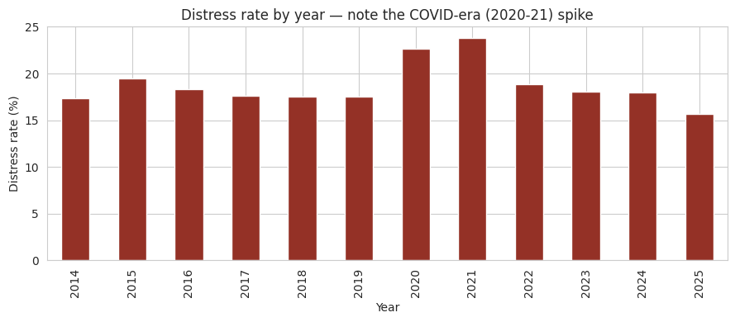
Note: Distress rate computed as the percentage of firm-year observations coded 1 under the composite distress label within each financial year. The COVID-19 era spike, FY2020 to FY2021, is visually apparent.
Prior to conducting the multivariate analysis, the mean values of some winzorized firm ratios and two firm characteristics were compared across either distressed or non-distressed firm-years using the appropriate parametric test, that is, Mann Whitney U test, which is appropriate considering the non-normal distribution commonly seen by financial ratios. The findings can be seen in Table 5.1.
This pattern shows that the amount of aggregate distress in Indian manufacturing companies doesn't remain constant but fluctuates along with the economic cycle, which means that a portfolio of manufacturing loans made in a stable year can be expected to deteriorate. For financial institutions, this means that they have to make necessary adjustments to the amount of provision made and the intensity of monitoring in anticipation of the macroeconomic stress rather than wait for firms to show signs of trouble, which is elaborated in Section 5.2.
Table 5.1: Univariate Comparison of Winsorized Financial Ratios and Firm Characteristics, Distressed versus Non-Distressed Firm-Years
Variable | Mean (Healthy) | Mean (Distressed) | Mann-Whitney p-value | Significant at 5%
Current ratio | 2.367 | 1.608 | < 0.001 | Yes
Working capital / Total assets | 0.209 | -0.131 | < 0.001 | Yes
Net worth / Total assets | 0.501 | 0.029 | < 0.001 | Yes
EBIT / Total assets | 0.106 | -0.036 | < 0.001 | Yes
Return on assets (PAT/TA) | 0.060 | -0.083 | < 0.001 | Yes
Sales / Total assets | 1.130 | 0.648 | < 0.001 | Yes
Interest coverage ratio | 38.828 | -0.592 | < 0.001 | Yes
CFO / Total assets | 0.065 | 0.017 | < 0.001 | Yes
Log (Total assets) | 5.732 | 5.174 | < 0.001 | Yes
Firm age (years) | 33.834 | 35.832 | < 0.001 | Yes
Note: Means computed on the year-wise winsorized ratio columns. All variables statistically significant at the 5% level under the two-sided Mann-Whitney U test, with exact p-values below 0.001 in every case and the smallest sample-size-adjusted p-value recorded for firm age (p = 6.45 x 10⁻⁹).
All ten variables examined had shown statistically significant differences between distressed and non-distressed firm-years at the 5 per cent level. The differences had been particularly clear for liquidity, solvency, profitability, and debt-servicing capacity. Distressed firm-years had recorded a lower average current ratio of 1.608, compared with 2.367 for non-distressed firms. Their working capital position had also been weaker, with working capital relative to total assets averaging -0.131, while a positive average of 0.209 had been recorded for non-distressed firms.
A similar pattern had been observed for solvency. The average net worth to total assets ratio had been only 0.029 for distressed firm-years, compared with 0.501 for non-distressed firms. This large difference had reflected the weaker balance-sheet position of distressed firms, with several observations having moved close to, or beyond, the point of balance-sheet insolvency. Profitability measures had shown the same pattern. EBIT to total assets and return on assets had both been negative on average among distressed firms, at -0.036 and -0.083 respectively. In comparison, non-distressed firms had recorded positive average values of 0.106 and 0.060.
The largest difference had been observed in the interest coverage ratio. Non-distressed firm-years had recorded an average interest coverage ratio of 38.828, whereas the average for distressed firm-years had been -0.592. This sharp difference had been consistent with the way the distress measure had been defined, where an interest coverage ratio below 1.0, together with a negative profit after tax, had been used as one of the conditions for identifying distress. Distressed firms had also been found to be somewhat smaller and older on average. However, these differences had been relatively small when compared with the much larger differences observed in liquidity, solvency, profitability, and debt-servicing measures.
To examine Hypothesis H1 while taking differences across industries and years into account, a multivariate logistic regression model had been estimated. The composite distress indicator had been used as the dependent variable, while the winsorized firm-level financial ratios and the two firm characteristics had been included as the main explanatory variables. Manufacturing Sector Group and financial year fixed effects had also been included, covering ten sector categories and twelve financial years respectively. This model had been referred to as Specification A and had been used as the primary specification for Objective 1.
By including these fixed effects, the analysis had controlled for changes that were specific to particular manufacturing groups and individual years. The specification had therefore provided a more conservative assessment of the relationship between firm-level financial indicators and financial distress, after accounting for differences in industry composition and the broader economic cycle. The estimated coefficients, odds ratios, and corresponding significance levels for the nine firm-level variables of interest had been presented in Table 5.2.
Table 5.2: Multivariate Logistic Regression Results, Specification A (Industry and Year Fixed Effects)
Variable | Coefficient (β) | Odds Ratio | p-value | Direction of Association
Net worth / Total assets | -4.393 | 0.012 | < 0.001 | Lower distress odds
EBIT / Total assets | -20.177 | ≈ 0.000 | < 0.001 | Lower distress odds
Return on assets | -13.996 | ≈ 0.000 | < 0.001 | Lower distress odds
Working capital / Total assets | -1.550 | 0.212 | < 0.001 | Lower distress odds
Sales / Total assets | -0.496 | 0.609 | < 0.001 | Lower distress odds
Log (Total assets) | -0.048 | 0.953 | < 0.001 | Lower distress odds
CFO / Total assets | 0.478 | 1.613 | 0.046 | Higher distress odds
Firm age | 0.003 | 1.003 | 0.006 | Higher distress odds
Current ratio | 0.001 | 1.001 | 0.840 | Not significant
Note: Dependent variable is the composite distress label. Model estimated by maximum likelihood logistic regression with fixed effects for Manufacturing Sector Group (10 categories) and financial year (12 categories); coefficients for these controls are omitted for brevity. Odds ratios computed as exp(β). The raw odds ratios for EBIT/TA and return on assets display as approximately 0.000 because exp(β) assumes a theoretical 1-unit (100 percentage point) increase; a more realistic 0.10 (10 percentage point) increase in these ratios yields reductions in distress odds of 86.7% and 75.3% respectively, as discussed in the text.
Upon controlling for the effects of industry and year, it was found that, out of the nine firm-specific predictors examined, eight had been statistically significant predictors of financial distress at the five per cent level. The only predictor that had not been statistically significant was the current ratio, which had a p-value of 0.840. This indicated that the effect noticed in the earlier univariate analysis of the current ratio had been due to variation across industries and years rather than due to the significance of the variable by itself in explaining financial distress.
The net worth to total assets ratio had been identified as one of the strongest predictors in the regression model. With an increase of 0.10 in this ratio, corresponding to a ten percentage point change in ratio, the odds of experiencing financial distress would have been reduced by approximately 35.6 per cent. This finding was in line with the assumption about the nature of the net worth to total assets ratio serving as a measure of a firm’s book-value solvency, as well as being relevant for understanding financial distress.
Profitability indications have revealed a referred association of the protective nature. Thus, a 10 per cent increase in EBIT/assets has been related with approximately a 86.7 per cent reduction in the probability of distress. Also, a similar relationship may be noted with return on assets, which has shown a 10 per cent increase in this ratio resulting in approximately a 75.3 per cent decline in the probability of distress.
In terms of working capital to assets ratio, it has been discovered that an increase of 10 per cent in the ratio has correlated with an approximately 14.4 per cent reduction in the probability of distress. The influence of asset turnover measured as sales/assets has appeared to be weaker but still significant; in particular, a 10 per cent increase in this ratio has been associated with a 4.8 per cent reduction in the likelihood of distress. The size of the company has also revealed a mild effect on the probability of distress, thus, one unit increase in the log of total assets has led to a reduction in the probability of distress by approximately 4.7 per cent.
Two variables had shown an unexpected positive relationship with financial distress after differences across industries and years had been controlled for. Firm age had been positively and significantly associated with the likelihood of distress, with an odds ratio of 1.003 for each additional year of age and a p-value of 0.006. This result suggested that older manufacturing firms in the sample had not necessarily been more financially stable than younger firms once differences in sector and year had been taken into account.
Cash flow from operations to total assets had also shown a positive and statistically significant relationship with distress, with an odds ratio of 1.613 and a p-value of 0.046. This result had been different from the pattern observed in the univariate analysis presented in Table 5.1. One possible explanation was the presence of multicollinearity between CFO to total assets and the other profitability and solvency measures included in the regression. Since these variables were closely related, the coefficient for CFO to total assets may have reflected its relationship with the other variables after they had been considered simultaneously.
In Specification A, the year fixed effects had captured changes occurring over time without showing which macroeconomic factors were responsible for those changes. To examine the role of these factors more directly, a second model, referred to as Specification B, had therefore been estimated. In this specification, the year fixed effects were replaced by four macroeconomic variables: GDP growth, WPI inflation, the Economic Policy Uncertainty Index, and the industry Weighted Average Lending Rate. This allowed the individual relationships between these macroeconomic variables and financial distress to be examined directly.
However, the macroeconomic results had been based on only twelve financial years of observations. The coefficients from Specification B had therefore been interpreted with caution and treated as indicative rather than as strong or fully powered estimates. The results from this specification have been presented in Table 5.3.
Table 5.3: Multivariate Logistic Regression Results, Specification B (Macroeconomic Regressors Only)
Macroeconomic Variable | Coefficient (β) | Odds Ratio | p-value | Direction of Association
GDP growth (%) | -0.019 | 0.981 | 0.005 | Lower distress odds
Industry WALR (%) | -0.059 | 0.943 | 0.016 | Lower distress odds
EPU Index | 0.002 | 1.002 | 0.128 | Not significant
WPI inflation (%) | 0.000 | 1.000 | 0.971 | Not significant
Note: Firm-level ratio coefficients and Manufacturing Sector Group fixed effects are estimated jointly with the four macroeconomic regressors reported above but are omitted from this table as they are materially unchanged from Table 5.2. Odds ratios computed as exp(β).
Of the four macroeconomic variables examined, GDP growth and the industry Weighted Average Lending Rate (WALR) had been found to be statistically significant at the 5 per cent level. GDP growth had shown a negative and statistically significant relationship with financial distress, with a p-value of 0.005. A one percentage point increase in real GDP growth had been associated with an approximately 1.9 per cent reduction in the odds of distress. This result had suggested that financial distress among Indian manufacturing firms had tended to move in the opposite direction to the overall business cycle.
The industry WALR had also shown a negative and statistically significant relationship with distress, with a p-value of 0.016. A one percentage point increase in WALR had been associated with an approximately 5.7 per cent reduction in the odds of distress. Although this result may appear unexpected, it had been interpreted cautiously because the relationship had been estimated using only twelve years of macroeconomic data and may also have been affected by its close relationship with the broader business cycle. In contrast, neither the Economic Policy Uncertainty (EPU) Index nor WPI inflation had been statistically significant. The p-values had been 0.128 for the EPU Index and 0.971 for WPI inflation.
An important result had been that the firm-level variables had remained broadly stable between Specification A and Specification B. Their signs, magnitudes, and levels of significance had changed very little after the year fixed effects had been replaced with the four macroeconomic variables. For example, the coefficient for working capital to total assets had changed only slightly, from -1.550 to -1.546. This consistency had provided additional support for the firm-level results, suggesting that the main relationships had remained stable even after macroeconomic conditions had been included in the analysis.
Overall, the results had provided substantial support for Hypothesis H1. Eight of the nine firm-level variables had been found to have statistically significant relationships with financial distress. Solvency, profitability, and the working capital buffer had emerged as the strongest protective factors, while firm size had shown a smaller protective effect. The current ratio had not retained statistical significance after industry and year effects had been controlled for. At the same time, firm age and cash flow from operations to total assets had shown statistically significant positive relationships with distress, although these findings had been contrary to the expected direction and therefore required cautious interpretation.
Objective 2: Results
The discriminative performance of the three machine learning models and the two benchmark scores was evaluated on the held-out FY2022 to FY2024 test set using the area under the receiver operating characteristic curve, AUC, a threshold independent measure of a classifier's ability to distinguish distressed from healthy firm-years. The results have been reported in Table 5.5 and illustrated in Figure 5.2.
Table 5.5: One-Year-Ahead Distress Prediction Accuracy (AUC), Machine Learning Models versus Benchmark Scores, FY2022–FY2024 Test Set
Model | AUC | Feature Set | Rank
XGBoost | 0.889 | Firm + macro | 1
Random Forest | 0.887 | Firm + macro | 2
Logistic Regression | 0.857 | Firm + macro | 3
Springate S | 0.827 | Firm only (formula) | 4
Altman Z″ | 0.788 | Firm only (formula) | 5
Figure 5.2: Receiver Operating Characteristic Curves, Machine Learning Models (Firm + Macro Features) versus Altman Z″ and Springate S (Firm-Only)
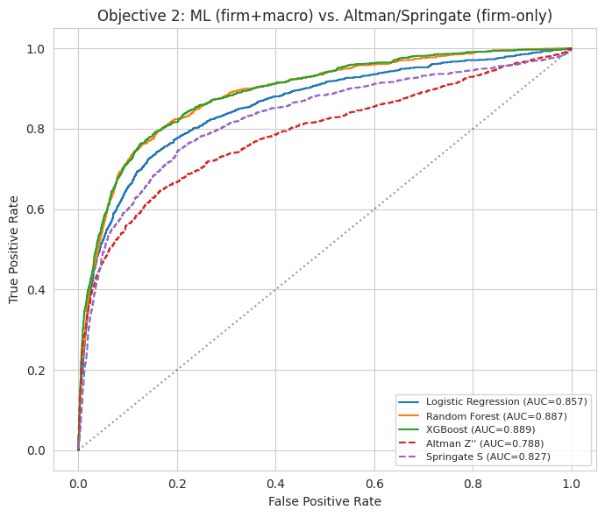
Note: Diagonal dotted line represents the performance of a non-informative, random classifier (AUC = 0.500).
All of the three machine learning models performed better than the two traditional benchmarks on the held-out test set. The best AUC score was provided by the XGBoost algorithm (0.889), while Random Forest followed closely behind with AUC of 0.887. Both models performed better than the Logistic Regression model, which recorded AUC of 0.857. Of the two traditional benchmark models, the Springate S-score had better results, with AUC of 0.827 as compared to 0.788 for the Altman Z″ book-value model. The fact that the Springate model had better performance can be explained with the fact that its formula includes current ratio as the short-term measure of profitability, which was not included in the Altman Z″ formula used in this case.
The distinction between the model XGBoost with the highest AUC of 0.889 and the Springate S-score as the most robust one among the benchmark models at 0.827 was 0.062 AUC points. Hence, the model had been able to deliver a significant uplift in differentiating companies with distress from those without one year in advance. However, the difference was relatively insignificant. The distinction was wider in the comparison of XGBoost and Altman Z″ model, where AUC had been 0.101 points. Nonetheless, comparisons were made not quite on the same premises due to the fact that machine learning models had had four additional macroeconomic variables, while conventional benchmark models utilized only fixed financial ratios.
For a financial institution reviewing several manufacturers that borrowed money from it, this level of accuracy improvement has helped achieve a better ranking based on which borrowers would default, hence providing the chance to focus scarce resources on the borrowers requiring closer credit monitoring instead of balancing it among the borrowers or, worse still, using a scoring method shown here as less effective.
To check if the macroeconomic variables impacted the models’ predictive performance, the XGBoost model was subsequently run by taking only the firm-level variables. In this version of the model, the four macroeconomic variables were excluded though the same held-out test set remained the same. The results of this comparison were summarized in Table 5.6.
Table 5.6: Firm-Only Ablation, Isolating the Marginal Contribution of Macroeconomic Features to XGBoost's One-Year-Ahead Predictive Accuracy
XGBoost Feature Set | AUC
Firm-level features only | 0.891
Firm-level + macroeconomic features (combined) | 0.889
Macro contribution (Δ AUC) | -0.002
Despite what the straightforward comparison in Table 5.5 implies, the introduction of four macroeconomic regressors in the list of XGBoost features has not enhanced but slightly reduced prediction accuracy in a twenty-four-month period. To start with, the AUC went down to 0.891 with only company characteristics and 0.889 with both company and macroeconomic characteristics, which is a difference of -0.002 AUC points. Hence, this change is negligible and falls within the boundaries of random estimation error. It is important to point out that although macroeconomic statistics are used only across twelve years of changes, it can be stated by now that practically all discriminative power of machine learning models used for prediction is based on financial fundamentals of the companies without macroeconomic data adding any significant forecasting value in the case when fundamentals are known in advance.
Because the AUC isn’t reliant on specific threshold values and is determined through rankings, the findings from the top performing XGBoost model—the model that uses the characteristics of a company along with several economic factors—were analyzed according to the default threshold of 0.5. This was necessary to verify the number of false negatives and false positive outcomes that could occur in the event that this model was used as an early warning system. The confusion matrix generated in this way is shown in Figure 5.3 while the results obtained are provided in Table 5.7.
Figure 5.3: Confusion Matrix, XGBoost (Firm + Macro Features), FY2022–FY2024 Test Set
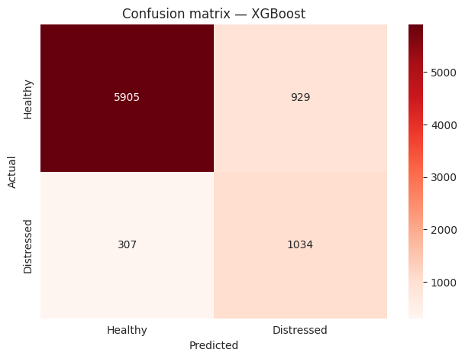
Table 5.7: Classification Performance Metrics Derived from Figure 5.3, XGBoost at the 0.5 Probability Threshold
Metric | Value | Interpretation
Accuracy | 84.9% | Proportion of all test firm-years correctly classified
Precision (distressed class) | 52.7% | Of firm-years flagged as distressed, share that were truly distressed
Recall / Sensitivity (distressed class) | 77.1% | Of truly distressed firm-years, share correctly flagged
Specificity (healthy class) | 86.4% | Of truly healthy firm-years, share correctly classified as healthy
F1-score (distressed class) | 62.6% | Harmonic mean of precision and recall
Note: Confusion matrix cell counts, test set n = 8,175: true negatives = 5,905; false positives = 929; false negatives = 307; true positives = 1,034.
With a standard probability threshold of 0.5, XGBoost could accurately predict 84.9% of tests. In terms of classification for recalled firms, it identified 1,034 of the 1,341 actual firm-year distress cases with a recall rate of 77.1%, while suffering from a precision level of only 52.7%. This means that more than half of the firms categorized as distressed, based on the model’s prediction, actually went through the distress process the following year. This happened because in the case of XGBoost, recall performance far exceeded precision, which is the preferred use of such models since the consequences of missing an actual distressed firm far outweigh the consequences of mistakenly identifying a healthy firm as distressed.
For an organization utilizing this system as an early-detection mechanism, a precision level of 52.7% means that nearly half of the flagged accounts that are chosen for examination will turn out to be incorrect; however, it has been considered to be a reasonable cost of doing business because the model has been able to detect more than three-quarters of the companies that became truly distressed.
Hypothesis H2 has been confirmed, as the AUC values presented in Table 5.5 indicate that Random Forest and XGBoost exceeded the benchmark parameters. However, it is worth noting that XGBoost has outperformed the first benchmark by 0.062 and the second one by 0.101 AUC points. Random Forest's performance is lower in this case since its advantage over the benchmark parameters was quantified as merely 0.060 and 0.099 AUC points respectively; nevertheless, Logistic Regression has delivered a result that is equal to 0.030 AUC points compared to Springate S.
Objective 3: Results
Each of the fourteen candidate features was mapped to one of eight indicator categories for the purpose of aggregating SHAP importance, as reported in Table 5.8.
Table 5.8: Mapping of Individual Features to Indicator Categories for SHAP Aggregation
Indicator Category | Feature(s) Assigned
Liquidity | current_ratio, wc_ta
Leverage / Solvency | nw_ta
Profitability | ebit_ta, roa
Efficiency | sales_ta
Cash flow | cfo_ta
Debt service | icr (interest coverage ratio)
Firm characteristics | log_assets, firm_age
Macro | gdp_growth, wpi_inflation, epu_index, walr
The mean absolute SHAP value of each feature, computed across all 8,175-test set firm-years, was used as the summary measure of that feature's overall contribution to the model's one-year-ahead distress predictions. The full feature level ranking has been reported in Table 5.9 and illustrated in Figure 5.4.
Table 5.9: Feature Ranking by Mean Absolute SHAP Value, XGBoost (Firm + Macro), FY2022–FY2024 Test Set
Rank | Feature | Category | Mean |SHAP|
1 | Interest coverage ratio (icr) | Debt service | 0.838
2 | Return on assets (roa) | Profitability | 0.640
3 | Net worth / Total assets (nw_ta) | Leverage / Solvency | 0.394
4 | Sales / Total assets (sales_ta) | Efficiency | 0.268
5 | EBIT / Total assets (ebit_ta) | Profitability | 0.251
6 | CFO / Total assets (cfo_ta) | Cash flow | 0.164
7 | Current ratio | Liquidity | 0.144
8 | Log (total assets) | Firm characteristics | 0.120
9 | Industry WALR | Macro | 0.118
10 | WPI inflation | Macro | 0.112
11 | Firm age | Firm characteristics | 0.091
12 | GDP growth | Macro | 0.084
13 | Working capital / Total assets (wc_ta) | Liquidity | 0.046
14 | EPU Index | Macro | 0.033
Figure 5.4: Feature Importance, Mean Absolute SHAP Value by Feature (Macro Features Shown in Orange)
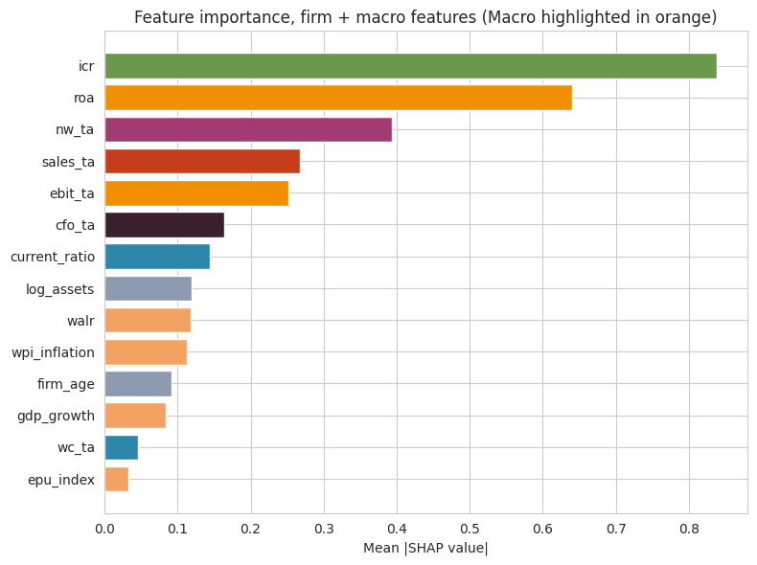
In this analysis, interest coverage appears with an impressive margin as the strongest predictor of distress in the year ahead, boasting the average absolute SHAP value of 0.838 that is 30.14 percent greater than that of the second feature on the list, return on assets (0.640). The following most influential features after interest coverage ratio were net worth to total assets ratio, return on sales, EBIT and cash calculations, with working capital to total assets ratio and Economic Policy Uncertainty index demonstrating the least considerable predictive ability.
For the purpose of proper interpretation, it is worth mentioning that two features of utmost importance according to SHAP, i.e. interest coverage ratio and return on assets are not absolutely independent from the definition of distress label itself because return on assets shows its sign in relation to one of the two components of the definition of the label and interest coverage ratio is mentioned in one of its components. Since DISTRESS(t+1) rather than DISTRESS(t) that these ratios would directly imply serves as the dependent variable in this case, this ties were interpreted as real one-year-ahead predictive ties rather than manual data leakage. The only thing is that the high importance of these two parameters can be explained due to their proximity to being defined in relation to the desired outcome alongside their status of real economic indicators.
As a result, interest coverage ratio has emerged as the most crucial metric for a credit officer to keep an eye on, even more than size, liquidity and asset turnover, since it is the only ratio employed to signal firms that are inclined to go into distress and those that will be just fine.
While mean value of SHAP demonstrates the influence of each feature, the SHAP beeswarm diagram in Figure 5.5 shows the influence of each feature in terms of its direction in case of its four most important parameters.
Figure 5.5: SHAP Beeswarm Plot, Top Four Predictors of One-Year-Ahead Financial Distress
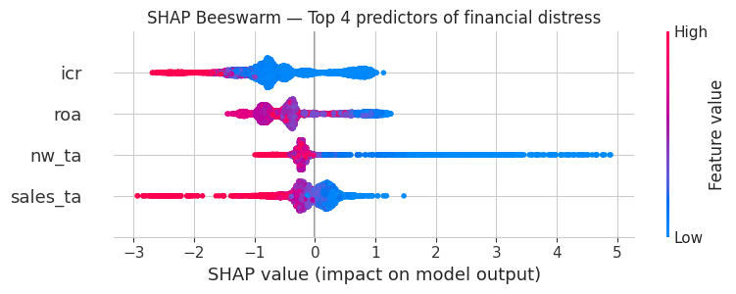
Note: Each dot represents one test-set firm-year. Horizontal position indicates the SHAP value, the impact on the predicted log-odds of distress in year t+1; colour indicates the underlying feature value, with magenta/pink denoting high values and blue denoting low values.
In the case of the top four predictors, there was a close adherence to the direction of effect that was indicated in Figure 5.5 and also to financial economics intuition and polarity presented in the Objective 1. High values of interest coverage settled on the negative side of the SHAP plot, which correlated with the decline of predicted distress risk, whereas low or negative values of interest coverage were placed on the positive side of the SHAP plot, causing a sudden increase in distress risk and a long right tail containing the extreme positive SHAP values related to the firm-years with diminished ability to service debt. The same situation was observed with the return on assets and the net worth to total assets predictors, where net worth to total assets exhibited the pronounced right tail with very high positive SHAP values belonging to the severely undercapitalized firm-years. The same was observed for sales to total assets, with the only difference being an insignificant range of SHAP values. No sign reversing phenomenon was observed for these predictors as well, which indicated a key difference from CFO/TA and firm age presented in Objective 1.
Since the direction of each of these predictors has been consistent with basic financial intuitions, a lender can interpret a falling interest coverage ratio, a decreasing return on assets, or a deteriorating net worth position as a reliable early warning indicator, rather than view them as something that needs to be explained as a flaw of the model. To find out which type of indicator out of eight possible types attracted the most interest in the model, SHAP values on the feature level has been summed for each indicator type and expressed as a percentage of the total of all absolute importance scores for different types of indicators. The results are summarized in Table 5.10 and Figure 5.6.
Table 5.10: Category-Level SHAP Importance, Share of Total, XGBoost (Firm + Macro), FY2022–FY2024 Test Set
Indicator Category | Share of Total SHAP Importance
Profitability | 27.0%
Debt service | 25.4%
Leverage / Solvency | 11.9%
Macro | 10.5%
Efficiency | 8.1%
Firm characteristics | 6.4%
Liquidity | 5.7%
Cash flow | 5.0%
Figure 5.6: Category-Level Importance, Share of Total SHAP Importance by Indicator Category
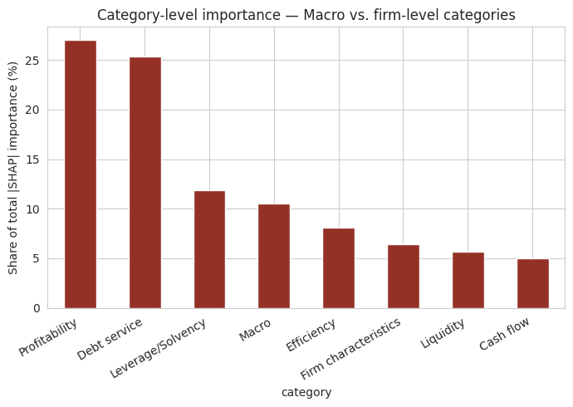

The importance of profitability and debt servicing in explaining the predictions of distress made by the model can be understood from the fact that they account for more than half of the overall SHAP importance of the model, thus confirming that the main drivers of the overnight distress predictions made by the model are the operating performance of companies and their overall profitability. This matches the finding from Objective 1 of the study that points towards a strong role of these variables in predicting distress. The third variable is leverage and solvency categories, which accounted for 11.9 percent while the newly introduced macroeconomic category took forth position accounting for 10.5 percent. All the other variables such as efficiency, firm characteristics, liquidity, and cash flows contributed less than 10 percent in total importance.
The SHAP figure of 10.5 percent representing macro category needs to be interpreted jointly with the firm-only ablation, which was reported in Objective 2. The ablation result indicated that the removal of the four macroeconomic regressors led to a mere -0.002 change in the AUC of the test set. When interpreted in isolation, the SHAP value of 10.5 percent might lead us to think that macroeconomic conditions are relatively important independent determinants of the model’s predictions. However, when taking into account the ablation results, we can understand that the model has utilized macroeconomic regressors, mainly GDP growth and industry lending rate, rather than as new source of forecasting information, as a replacement of information already available from firm level ratios, namely, the rejected year identifier.
As a result, a critical decision regarding how the lender should use macroeconomic dashboards in practice is as follows: these measures are still useful for the evaluation of the vulnerability of the portfolio of manufacturing loans in general but do not add much to the identification of the company under a risk of default among the companies whose ratios are known, since the ratios of the company already reveal all the necessary information. The SHAP values at the category level confirmed the hypothesis H3 as a lack of equal contributions of the eight category indicators has been determined. In particular, profitability gained 27% of overall importance and cash flow got only 5%. As anticipated, profitability turned out to be the most significant category; leverage and solvency ended in the third place. In the process of partial revision of the hypothesis, a previously unknown variable concerning debt service gained the second position with its significance rate which was equal to 25.4%.
Objective 4: Results
The complete sample XGBoost model, utilizing company-specific and economic variables, trained on the years 2014-2021, and tested on 2022-2024, produced an AUC score of 0.889 corresponding to the results of the analysis from Objective 2, therefore reinforcing the fact that the reference model employed in this research is the same one that has been verified during the previous section of the analysis.
Separately AUCs were calculated for both the Subgroup model and the overall one for all ten groups related to the Manufacturing Sector, involving groups that had presented a minimum of 50 training data entries, 20 test entries, and in which both classes were present in the test sample. There are all ten groups meeting all of these requirements. The results were presented in Table 5.11 and illustrated in Figure 5.7.
Table 5.11: Distress Prediction Accuracy by Manufacturing Sector Group, FY2022–FY2024 Test Set
Sector Group | n (Test) | AUC (Within-Subgroup) | AUC (Full-Model Transfer)
Automotive & Auto Components | 385 | 0.867 | 0.966
Power & Electrical Equipment | 446 | 0.922 | 0.919
Diversified & Miscellaneous Manufacturing | 351 | 0.902 | 0.909
Others | 3,056 | 0.888 | 0.894
FMCG & Food Processing | 564 | 0.888 | 0.892
Heavy Engineering, Metals & Mining | 974 | 0.867 | 0.888
Construction Materials & Ceramics | 192 | 0.848 | 0.868
Chemicals, Petrochemicals & Pharmaceuticals | 1,078 | 0.858 | 0.863
Plastics, Rubber & Packaging | 484 | 0.819 | 0.854
Textiles, Apparel & Leather | 645 | 0.851 | 0.847
Figure 5.7: Model Transferability, Full-Sample Reference Model AUC by Manufacturing Sector, with Full-Sample Baseline
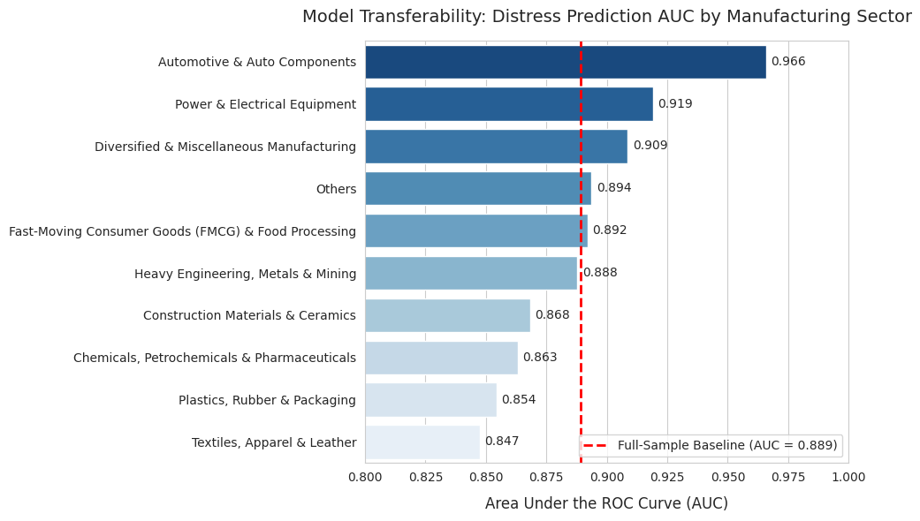
Using the complete sample reference model, various individual sectors showed AUCs ranging from 0.847 (Textiles, Apparel and Leather) to 0.966 (Automotive and Auto Components). There is a difference of 0.118 in AUC points between the highest and lowest performing sectors. The following six sectors- Power and Electrical Equipment, Diversified and Miscellaneous Manufacturing, Others, FMCG and Food Processing, Heavy Engineering, Metals and Mining, and Automotive and Auto Components, had transfer AUCs equal to or greater than the baseline transfer AUC. The last four sectors, namely Construction Materials and Ceramics, Chemicals, Petrochemicals and Pharmaceuticals, Plastics, Rubber and Packaging, and Textiles, Apparel and Leather, had transfer AUC scores lower than the baseline. However, Textiles, Apparel and Leather had the lowest transfer AUC score of 0.847 and a within subgroup AUC score of 0.851, which apparently was not different than the transfer AUC score that suggests that the sector's lower predictability was not simply due to the use of a pooled model. The Automotive and Auto Components Sector showed the highest difference in its within subgroup AUC score of 0.867 as compared to its transfer AUC of 0.966 in any of the sectors thereby indicating that the pooled full sample model performed better than any sector model thus indicating over fitting of the sector-specific model due to unavailability of training samples as opposed to the shortcomings of the pooled model.
In conclusion, the distribution of 0.118 AUC points between sectors suggests that the model is not entirely sector agnostic, thus predictions regarding Textiles, Apparel, and Leather, need to be observed with more care than predictions concerning Automotive and Auto Components or Power and Electrical Equipment. Nevertheless, the distribution is still quite moderate in absolute terms as the predicted AUC for each of the sectors analyzed is well over 0.80, and in nine out of the ten cases, it is higher than the best benchmark value obtained for the strongest firm in Objective 2 – the Springate S value amounting to 0.827.
For a bank utilizing this model in a varied manufacturing portfolio, it has indicated that a single standard threshold is not suitable in every industry, with the flagged accounts specifically in the Textiles, Apparel and Leather industry qualifying for lower standards for manual investigation compared to other industries such as Automotive and Auto Components where the effectiveness of the approach has already been proven. The same tests with the same subgroup and full model transfers were conducted for the pre-IBC and post-IBC split, which is marked by the enactment of the Insolvency and Bankruptcy Code in December 2016, where the Pre-IBC regime corresponds to the fiscal years 2014 to 2016 and the Post-IBC regime corresponds to the fiscal years 2017 onward. The obtained results are summarized in Table 5.12.
Table 5.12: Distress Prediction Accuracy by Pre-/Post-IBC Regime, FY2022–FY2024 Test Set
IBC Regime | n (Test) | AUC (Within-Subgroup) | AUC (Full-Model Transfer) | Note
Post-IBC | 8,175 | 0.890 | 0.889 | —
Pre-IBC | 0 | - | - | Insufficient post-2021 observations in this regime split
The chronological train test separation, where particular regard was given to the training data, which came entirely before the financial year 2022, limited the possibility of testing out-of-sample predictive capability. Subsequently, this led to the post-IBC test separating the entire sample test which was also n = 8,175, producing the same AUC results. However, the issue still remains regarding true cross-regime transferability.
Given that the COVID-19 years (2020-2021) were entirely covered by the chronological training period utilized elsewhere in this work, the alternative, period-based experimental design was applied in this instance only: within each of the COVID and non COVID subsamples, 70/30 training/test splits were made, where the seeds were fixed for reproducibility. After that, the separate XGBoost model was built and tested within each 70/30 split.
Table 5.13: Distress Prediction Accuracy, COVID-19 versus Non-COVID Periods (Within-Period 70/30 Split)
Period | n (Test) | AUC (Within-Subgroup)
COVID (FY2020–FY2021) | 1,614 | 0.892
Non-COVID (all other years) | 7,154 | 0.911
The model is successful in illustrating remarkable discriminatory ability in both periods, having shown a small gap in favor of non-COVID cases with 0.911 metric compared to COVID-ones with 0.892 metric, which means predicting one year ahead distress was a bit more difficult during the COVID period than in other years, though all indicators are higher than 0.827 indicator of the Springate S benchmark.
In particular, a logistic regression was used to analyse whether the high level of COVID period distress already described in Figure 5.1 could be explained by the impact of the economic crisis of that period (GDP and EPU) or was a special effect of pandemic. Two econometric specifications have been compared, namely basic regression for the current distress with the help of winsorized ratios, a dummy indicating the COVID period, and Manufacturing Sector Group fixed effects and an expanded regression adding four economic indicators to the same model. The results are shown in Table 5.14.
Table 5.14: COVID-Period Dummy Coefficient, With and Without Macroeconomic Controls
Specification | COVID Dummy Coefficient | p-value | Significant at 5%
Without macro controls | 0.252 | < 0.001 | Yes
With macro controls (GDP growth, WPI, EPU, WALR) | 0.099 | 0.479 | No
In the absence of macroeconomic controls, the COVID period dummy variable had a large and statistically significant coefficient of 0.252 (p < 0.001). Therefore, this indicates that considering firm-level ratios and sector composition, the COVID era had considerably greater distress probabilities as compared to the other years. However, when controls such as GDP growth, wholesale price hike, EPU Index, and the average industry WALR were introduced into the model, the coefficient dropped by about 61 percent (0.099) and became statistically insignificant (p = 0.479). The above observation indicates that the heightened level of distress rate during the time of COVID could be largely accounted for by the collapse in GDP growth rates and a spike in the EPU index, and not due to some other mechanism that came about due to the pandemic separately from the general macroeconomic shock.
When analyzed as a group, the different types of robustness discussed above helped shed light on the discrepancies in robustness identified in the two specific checks. The sector group test was able to demonstrate considerable heterogeneity, which allows for caution in using the pooled model to the sector of Textiles, Apparel, and Leather while not making the model inapplicable for other sectors. The IBC check could only be used within the limits of the chronological hold out design, which does not allow estimating the validity of transferability across a variety of rules in regimes. Finally, the check related to COVID showed that the model was able to show a stable level of accuracy in the years of COVID as well as in the years before the pandemic, and both test results demonstrate a significant finding in the chapter in that the COVID-related instance of distress can be explained more with the help of macroeconomic factors than using any structural reasons for the emergence of the pandemic-related distress spike.
Hypothesis H4 was partially shown to be correct based on these outcomes. The model revealed significant performance differences among manufacturing sectors, with predictive accuracy being much different for the ten sector groups, with that accuracy ranging from 0.847 to 0.966 AUC. However, differences across periods were mostly attributed to macro level surprises rather than due to a specific structural break that occurred in the COVID-19 period or post-IBC legal regime. The comparison between pre and post-IBC regime could not be tested within the limits of chronological holdout design and was left as an open question for future studies instead of being treated as either support or opposite to the hypothesis.
5.2 Findings and Contribution
Summary of Key Findings
Hypothesis H4 was partially shown to be correct based on these outcomes. The model revealed significant performance differences among manufacturing sectors, with predictive accuracy being much different for the ten sector groups, with that accuracy ranging from 0.847 to 0.966 AUC. However, differences across periods were mostly attributed to macro level surprises rather than due to a specific structural break that occurred in the COVID-19 period or post-IBC legal regime. The comparison between pre and post-IBC regime could not be tested within the limits of chronological holdout design and was left as an open question for future studies instead of being treated as either support or opposite to the hypothesis.
In its examinations of prediction, Objective No. 2 determined that on a held-out test set of the following year, XGBoost achieved 0.889 in AUC, which significantly surpassed the Altman Z″ book value score (0.788) and the Springate S-score (0.827). This outcome confirmed that a modern and non-linear machine-learning classifying method is more precise in predicting the distress of firms than either of the two conventional scoring systems presently used in academia and the industry.
By using SHAP-based analysis on the resulting XGBoost model for the objective 3 regarding explainability, it has been determined that the interest coverage ratio is the foremost significant standalone predictor of financial distress occurring a year later, being more important than any other ratio or macroeconomic indicator examined. With regard to the categories, debt service was responsible for 25.4% of the model’s total decision-making power, just behind profitability (27.0%) but ahead of all other ratios, including leverage and solvency, efficiency, liquidity, and cash flow. Thus, it can be concluded that debt servicing capacity is the most important factor leading to financial distress in Indian manufacturing companies, rather than factors like balance-sheet size or liquidity reserves.
The results of objective 4 on robustness revealed a remarkable result of the research: the Dame distress rates, recorded during the pandemic phase, were seen to pull up to their highest level ever - 23.8 percent in FY2021 vs. 18.73 percent on average over the sample. The COVID dummy variable was found to be significant by itself, coefficient 0.252, p < 0.001, however, after controlling for realized GDP growth and Economic Policy Uncertainty, it lost approximately 61% of its value and completely lost its significance, coefficient 0.099, p=0.479, therefore showing that the spike in distress rates during the pandemic was explained to a great extent by the sharp drop in GDP growth rather than existing as some independent and particularly COVID specific phenomenon.
Contribution and Recommendations for Stakeholders
The main contribution of the project comes from the evidence that proves that a modern-day early warning system based on machine learning can be developed for manufacturing distress prediction in India, by means of data available to financers and regulators, as well as such a system could be made understandable through explainable AI, instead of functioning as a black box. Hence, some recommendations can be given to the main interest groups involved in the research.
It is suggested that both commercial banks and the Reserve Bank of India should find alternatives to static Z-scores based on Altman and Springate for providing a quantitative foundation for granting loans and for monitoring credit risks of manufacturing borrowers. Instead, they are encouraged to transition towards the use of modern systems using machine learning technologies that have been elaborated upon within the scope of this Project and which have been demonstrated to perform significantly better than traditional scores in real conditions of out-of-sample testing. In this regard, it is advisable to use the interest coverage ratio as the main variable for monitoring. In line with the results obtained through the explainable AI analysis conducted under Objective 3, the importance of the interest ratio proves to be greater than that of any other variable for making predictions and thus initiatives related to any changes in it should be prioritized over all other aspects of credit risk monitoring.
It is recommended to the manufacturing CFOs and top management to keep a high equity cushion, which means behaving in the manner so as to ensure a strong net worth to total assets position, as well as to pay off obligations in the most disciplined manner, which is far more important in avoiding financial troubles than gaining cash liquidity, which can be measured as a current ratio but was shown in this Project to be weak and untrustworthy once profitability, solvency, and other industry factors are taken into consideration. Therefore, the recommendation is given to manage capital allocation and financing in accordance with the aim of maintaining and growing the equity base and properly managing interest payments in relation to earnings from operating activities.
Given that financial distress experienced by various Indian manufacturing firms has been significantly and unequivocally linked to the growth of GDP and uncertainty of economic policy in the country, policymakers are suggested that the use of countercyclical monetary policy and consistent regulatory and policy certainty are both very effective measures to control the distress of the manufacturing industry. Findings from Objective 4 shows how the distress spike seen during the COVID period is mainly associated with the experienced macroeconomic shock rather than with the specific structural change that emerge during that moment and how the measures allowing to calm the aggregate demand and reduce uncertainty of the policy are likely to have direct and measurable effect on general distress and insolvency of the industry.
5.3 Conclusions
Conclusion 1: The Supremacy of Machine Learning Over Traditional Linear Models
The findings gathered as part of Objectives 2 and 3 support the conclusion that classic linear scoring models, no matter how valid they are in theory or practice, fail to deal with the complex realities of the manufacturing sector in such a large and diverse emerging economy as that of India. The Altman Z” and Springate S models are based on a fixed linear function of a couple of ratios, which were verified many years ago on developed country samples. The project’s results demonstrate that the contemporary model, based on non-linear technology such as XGBoost, allows for far better distinguishing between the distressed and normal firms than the afore-mentioned models. This feature is not just statistical. The SHAP analysis completed in Objective 3 illustrates that the machine learning model has been able to capture genuine non-linear interactions, particularly with regard to the interest coverage ratio, which linear models are not able to grasp. Accordingly, non-linear tree-based models have been found to represent a significantly more suitable basis for distress early warning systems in manufacturing than static linear models.
Conclusion 2: Macroeconomic Variables Explain Contemporaneous Distress but Add Little to One-Year-Ahead Prediction
From reading the results of Objectives 1, 2 and 4 together, a second conclusion can be inferred. It has been established that macroeconomic factors such as GDP growth and Economic Policy Uncertainty play a significant role in determining why periods of economic distress occur: the findings regarding Objective 1 showed that GDP growth correlated with economic distress, whereas the findings regarding Objective 4 demonstrated that the distress experienced in the COVID era can practically be attributed to macroeconomic shocks experienced during this period. However, remedial macroeconomic factors did not produce satisfactory results in the machine learning constructs used for predicting distress in one year: the ablation study for Objective 2 showed that the model on the basis of ratios relevant at the individual firm level (in terms of firm's performance) was able to achieve AUC equal to 0.891, against 0.889 achieved when installing the four macroeconomic variables in one model. The most likely reason behind the perceived tension is as follows. By the time a firm’s balance sheet and income statement indicate the presence of a negative macroeconomic environment, the latter has already affected the former. A decrease in GDP and an increase in uncertainty in policy-making have negative implications for a firm’s revenues, profit margins and interest coverage ratios. It is these ratios that contain the unique predictive value of the emerging macroeconomic conditions, rather than the other way round. Thus it can be said that while macroeconomic conditions are key to an understanding of the timing and intensity of distress cycles in the economy, they become rather irrelevant for predicting the distress of an individual firm.
5.4 Suggestions for future work
Future research should consider several extensions to this project. The first one is to use an artificial neural network (ANN) classifier, which includes the analytical paradigm acknowledged in the methodology of this project, based on the same features and split of the data, and compare the results with those of the XGBoost and Random Forest models studied in this project. The second extension is to use an appropriate statistical technique, such as the DeLong test, to make the comparison between machine learning methods and benchmarks described under Objective 2 fully rigorous. The third extension is to design a robustness test comparing the pre- and post-IBC periods, for which an in sample split in the same time frame or a test –train split that would allow having observations on both sides of the split in both groups can be used.
Fourth, the classification threshold used to prepare the confusion matrix under Objective 2 was the default threshold of 0.5 and was not specifically optimised for this study. Future research could examine whether a different threshold may be more appropriate by considering the relative costs of false positives and false negatives. For example, a cost-weighted precision-recall analysis could be used to identify a threshold that better reflects the practical requirements of banks or regulators. Such calibration would be important before the model is considered for use as a practical early-warning tool. Finally, future research could apply the present framework to other sectors of the Indian economy and to other emerging markets that experience similar macroeconomic uncertainty and volatility. This would help determine whether the strong importance of debt-servicing capacity, and the limited additional contribution of macroeconomic variables to one-year-ahead prediction observed in this study, are specific to Indian manufacturing or are also found in other economic and market settings.
5.5 Limitations
First, a limitation related to data availability affected the Altman Z″ solvency measure. The CMIE ProwessIQ extract used in this study did not report interest-bearing total debt separately. Therefore, total liabilities, calculated as total assets minus net worth, were used instead of total debt in calculating the net worth to total liabilities ratio. This was a broader measure because total liabilities included both interest-bearing and non-interest-bearing obligations, such as trade payables and provisions. The ratio used in this study should therefore be understood as a general measure of solvency rather than a precise measure of leverage in the narrower sense used in Altman's original formulation.
Second, a limitation was present in the pre- and post-IBC robustness analysis conducted under Objective 4. The chronological train-test split used in the study assigned financial years up to 2021 to the training period and reserved the years after 2021 for out-of-sample testing. Since the pre-IBC period covered only FY2014 to FY2016, no pre-IBC observations were available in the test set. As a result, the model's ability to perform on an unseen pre-IBC sample could not be tested within the chronological framework used in the study. The comparison between the pre- and post-IBC periods should therefore be interpreted with caution and should not be treated as conclusive evidence of either model stability across regulatory regimes or differences in performance between the two periods.
Third, the measure of financial distress used in the study was a constructed accounting-based proxy rather than an observed legal insolvency event. A firm-year was classified as distressed when the firm had negative net worth or when it recorded an interest coverage ratio below one together with a reported loss. This measure was intended to identify signs of financial difficulty before a firm reached the stage of formal insolvency proceedings. However, the measure was different from an actual event such as the initiation of Corporate Insolvency Resolution Process proceedings under the IBC. The distress indicator was also not directly validated against NCLT or IBC filing records for the firms included in the sample.
Fourth, the sample was constructed using a purposive sampling approach. Only listed manufacturing companies with at least eight years of continuous financial data in the CMIE ProwessIQ database were included. Although this condition was necessary to construct a sufficiently long and usable panel, it may have introduced survivorship bias. Firms that left the sample early because of delisting, acquisition, financial collapse, or other reasons may not have been included if they did not have eight years of continuous data. The findings should therefore be interpreted mainly in relation to established and continuously listed manufacturing firms and may not apply to newly listed firms or firms that had already exited the market.
Finally, no formal statistical test was conducted to determine whether the differences in AUC reported under Objective 2 were statistically significant. For example, a test such as the DeLong test for correlated ROC curves could have been used to formally compare the performance of XGBoost and the benchmark models. Although the AUC results were consistent with Hypothesis H2 and showed better performance for XGBoost than the two benchmark scores, the statistical significance of these differences was not formally tested in this study. The reported differences should therefore be interpreted as differences in observed predictive performance rather than as formally tested differences in model accuracy.

